Lab 2: Containerization & Kubernetes Orchestration
Task 2: Implement Kubernetes deployment

1. Objective
Perform a rolling update, a rollback, and scale the application replicas.

2. Rolling update
A version 2.0 image was built (different welcome message) and the deployment image was updated. Kubernetes replaced the pods gradually (maxSurge 1, maxUnavailable 1).
docker build -t lab2-python-app:2.0 app-v2
minikube image load lab2-python-app:2.0
kubectl set image deployment/lab2-app web=lab2-python-app:2.0
kubectl rollout status deployment/lab2-app
kubectl rollout history deployment/lab2-app

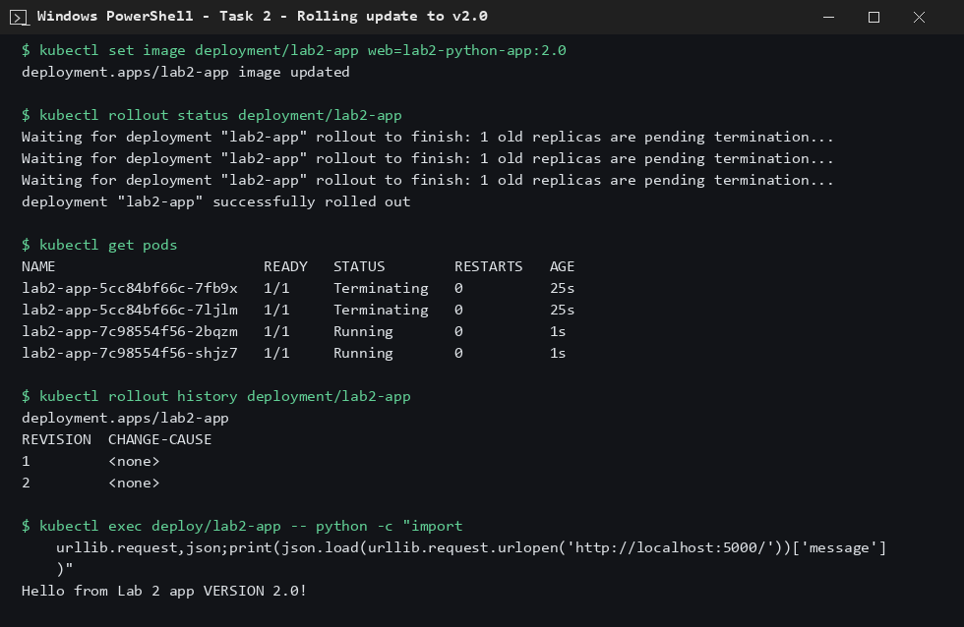
Figure 1: Rolling update to v2.0; app now returns the VERSION 2.0 message

3. Rollback
The rollout was undone and the deployment returned to image v1.0.
kubectl rollout undo deployment/lab2-app
kubectl rollout status deployment/lab2-app

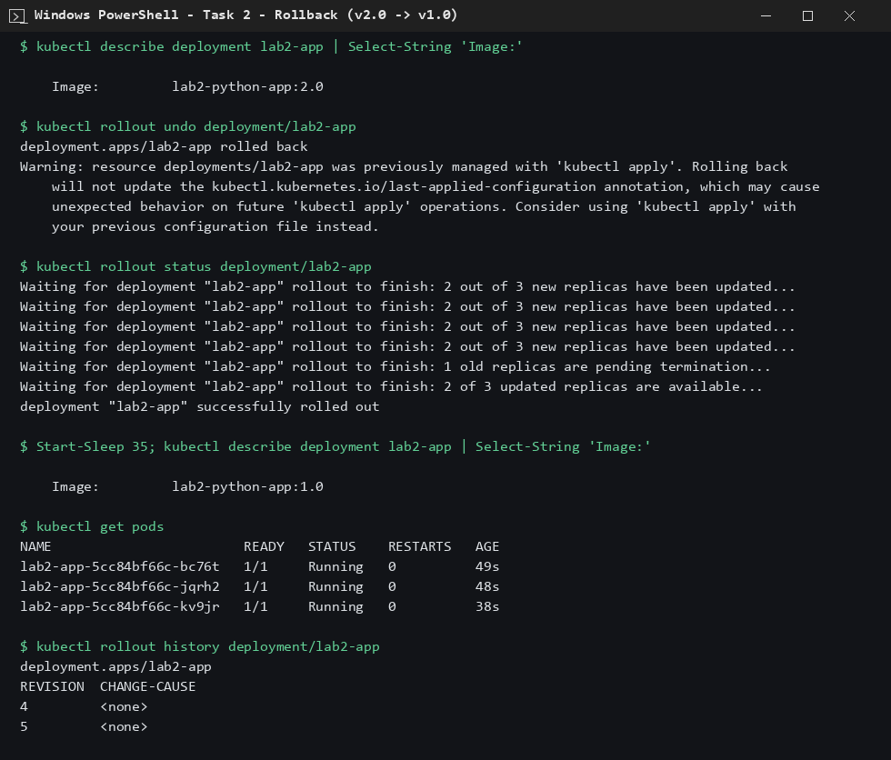
Figure 2: Rollback from v2.0 to v1.0

4. Scaling
The deployment was scaled up from 2 to 5 replicas and then down to 3.
kubectl scale deployment/lab2-app --replicas=5
kubectl scale deployment/lab2-app --replicas=3

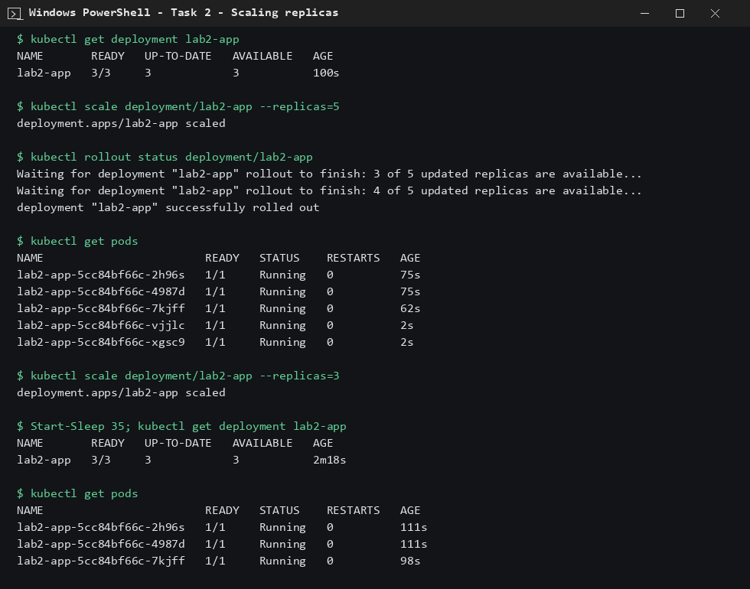
Figure 3: Scaling to 5 replicas and back to 3

5. Conclusion
Rolling update, rollback and scaling were all completed successfully.

